Task 01:

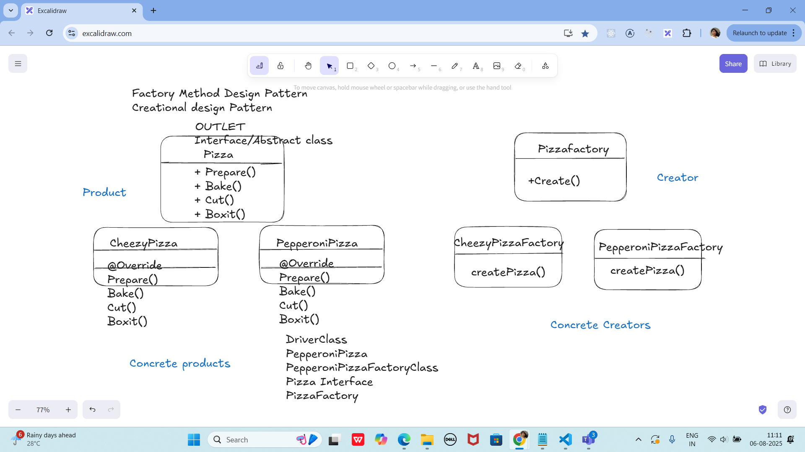

On the basis of above SS try to create a factory Method Design Pattern program

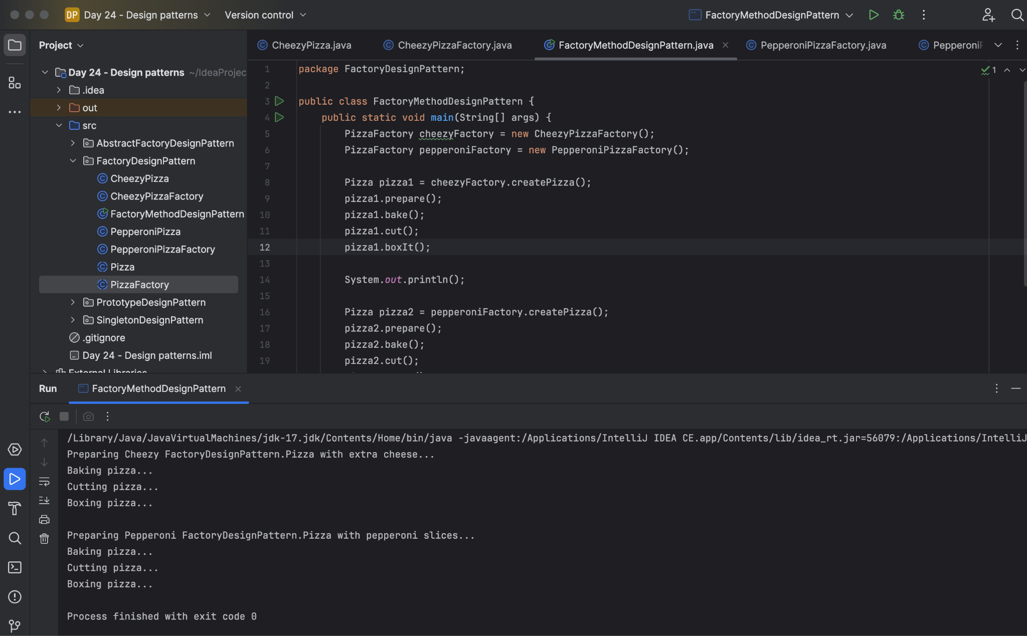
Singleton

Task 02:

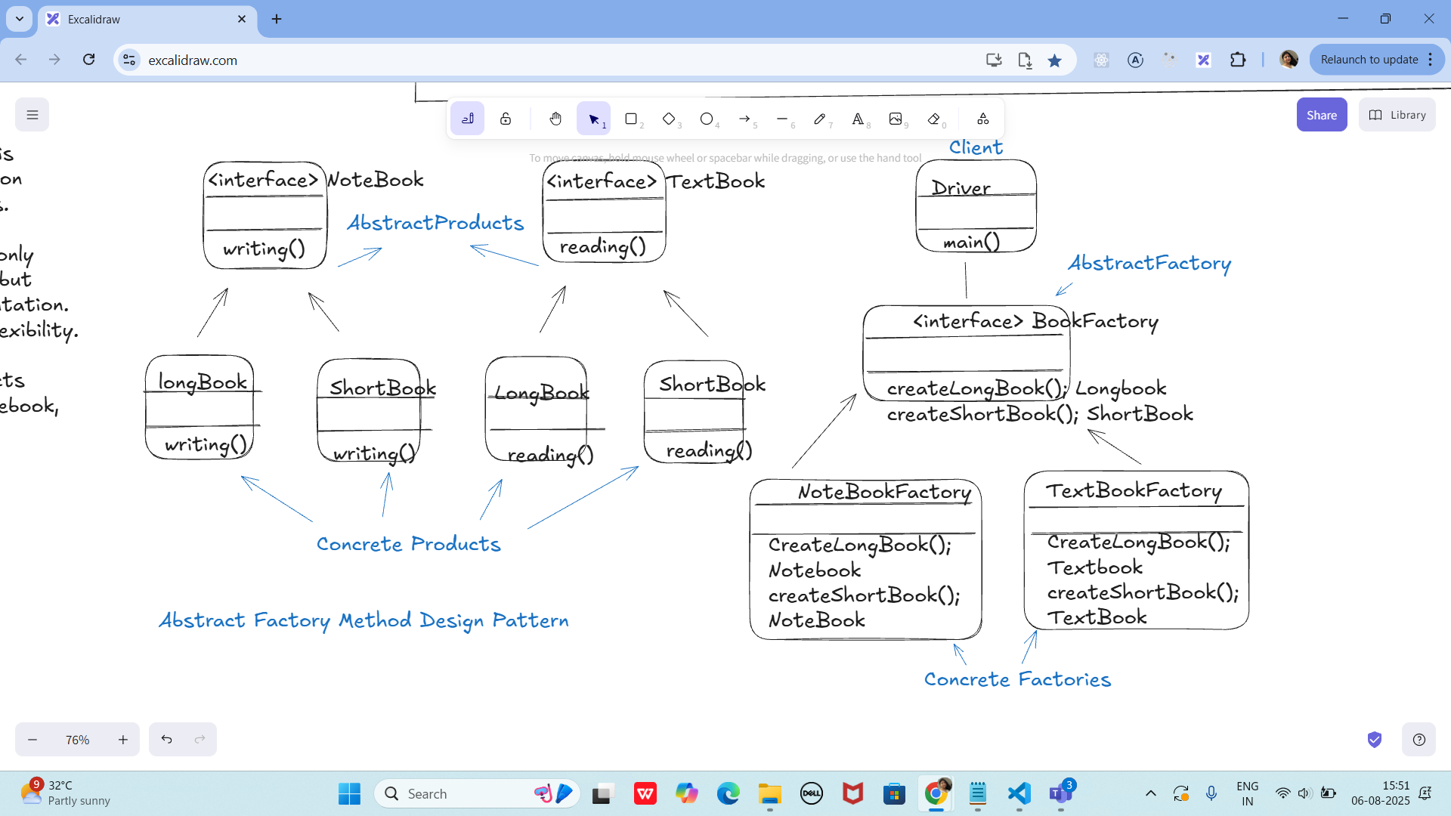

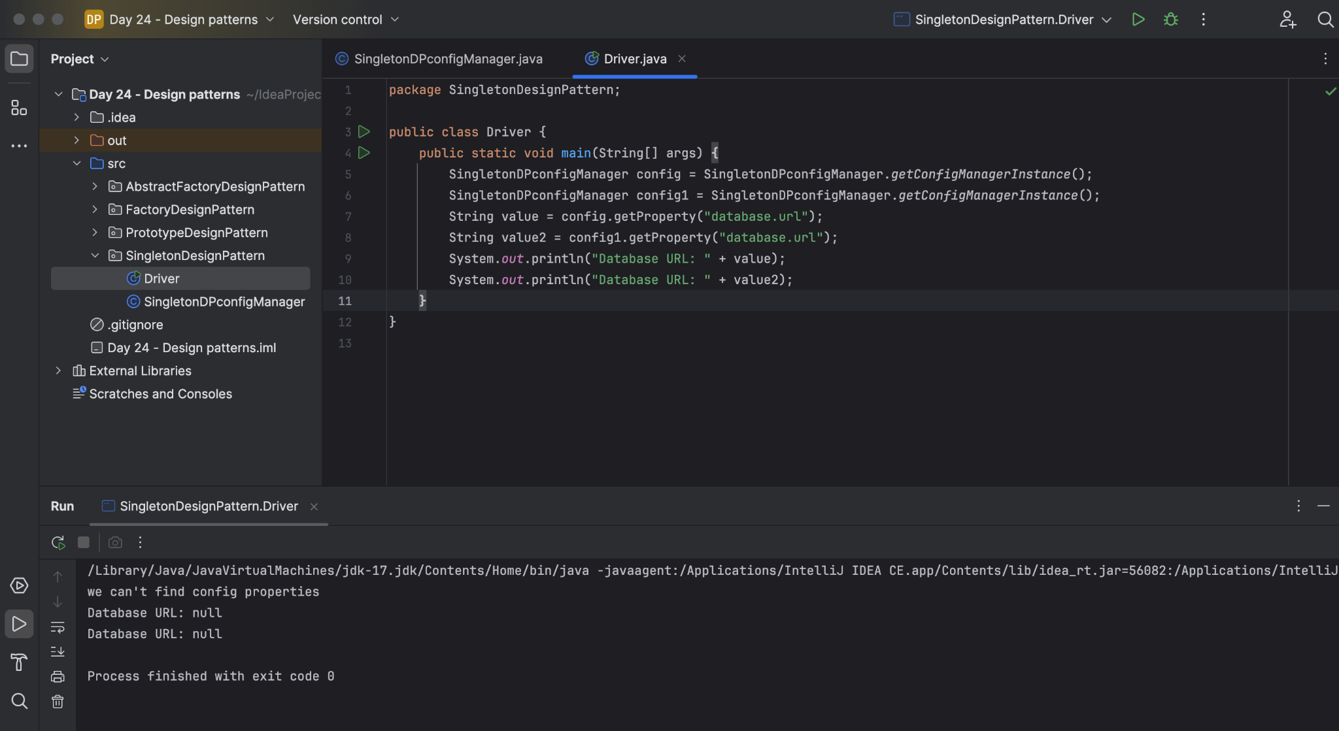

Task 03:
Abstract Factory Method Design pattern
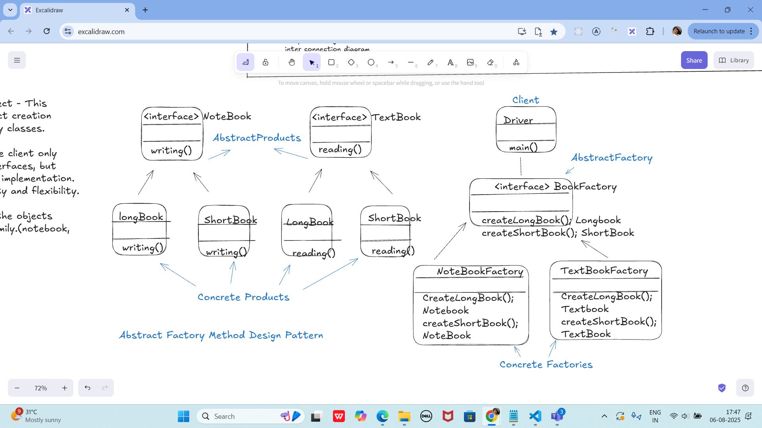

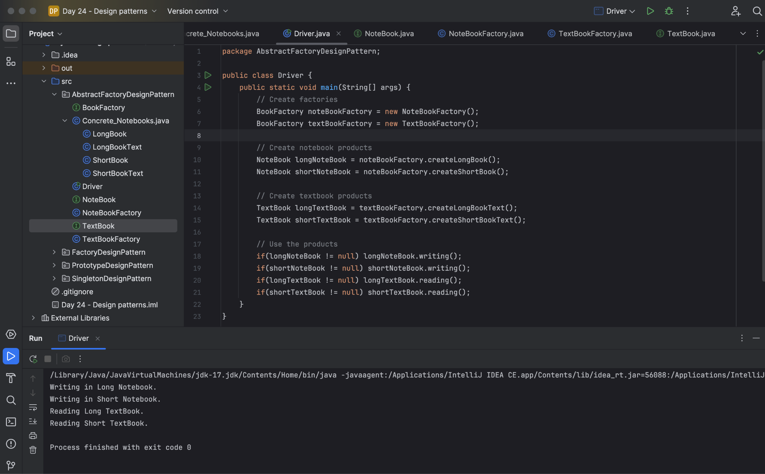

Write a code for the above implementation

Task 04:

Prototype Design pattern

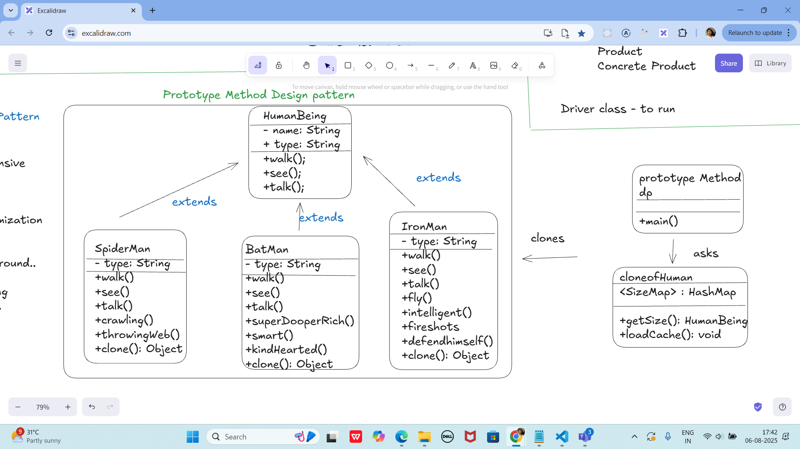

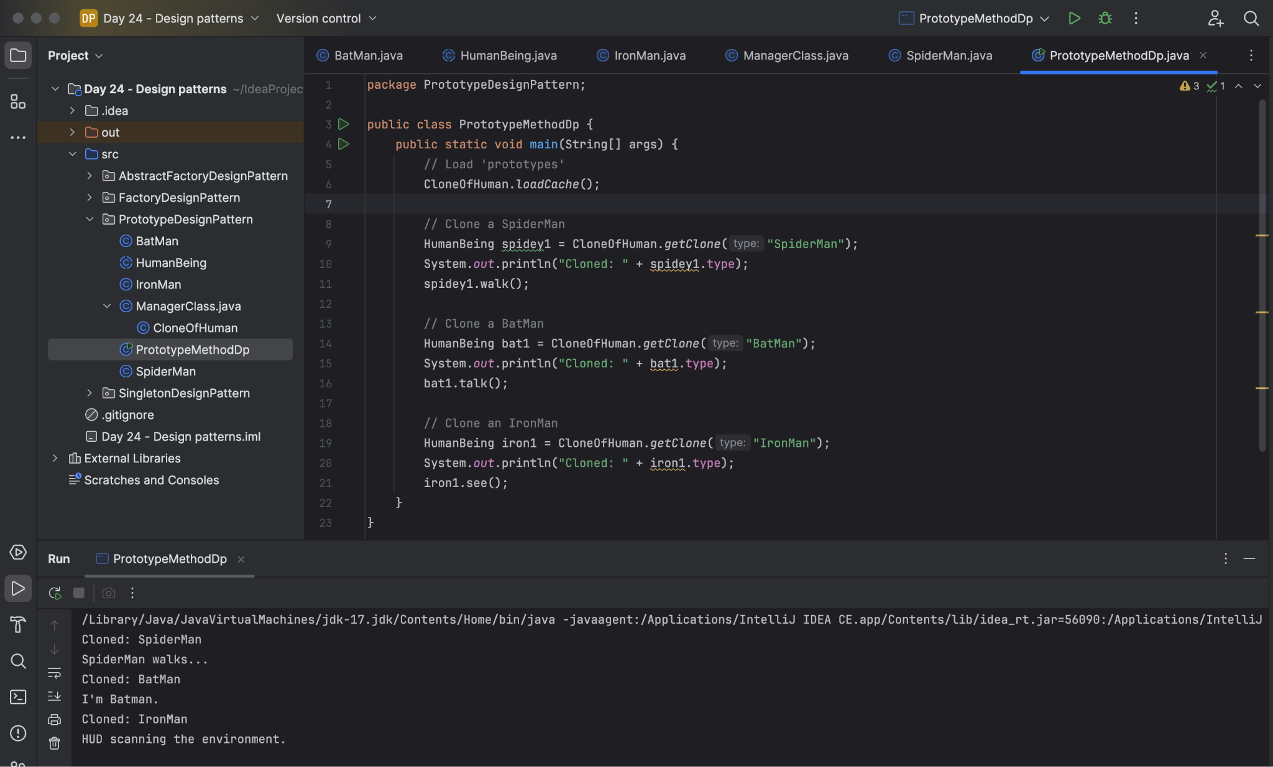

Task 05:

UML
@startuml
participant Pax as p
actor Actor as a #Green
boundary Boundary as b
control C as c
database Dbase as db
entity table as t
collections col as c
queue que as q

autonumber
p -[#red]> a : pax to actor
a ->x p: ohh is it!
autonumber 100
b ->> p: boundary to pax
note left: plz make a note on left
c -\ p: control to pax
db \\- p: db to pax
autonumber 50 10
t //-- db: table to db
c ->o db: collection to db
note right: plz make a note
q <->o p: q to pax

Prasunamba -> Batch1 : learning uml
Batch1 -> Prasunamba: ok will learn
@enduml

